Issue 13:
The Hierarchy of Controls:
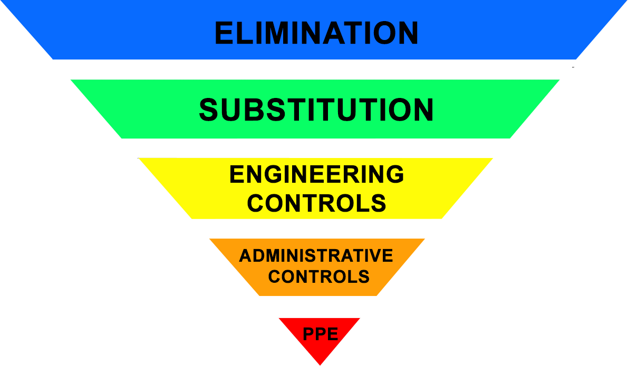
The latest update to the National PHE IPC guidance for the management of COVID-19 was launched at the beginning of June 2021. There are no changes to the type of or level of PPE required in this update but there is an increased focus upon the implementation of the ‘Hierarchy of Controls’.

The hierarchy of controls are a set of controls, presented in order, to control a given risk. In this situation the risk is COVID-19, but the risk can be anything. The controls in the hierarchy are always the same with the most effective risk reduction control (elimination) appearing first in the hierarchy.

Control | What does this mean?
1.Elimination | Redesign the job or substitute a substance so that the hazard is removed or eliminated
2.Substitution | Replace the process with a less hazardous one
3.Engineering Controls | Controlling aspects of the environment such as water supply or ventilation etc.
4.Administrative controls | These are all about identifying and implementing the procedures you need to work safely. For example developing policies and procedures for managing patients with COVID-19, signage to indicate maximum room occupancy, social distancing posters etc..
5.Personal Protective Equipment (PPE) | Use of PPE should only be considered when all other controls are exhausted and where the risk can’t be adequately controlled without it

The controls should always be worked through systematically with the last control, PPE, only being utilised where the other controls cannot reduce the risk sufficiently. If PPE is required all other controls should also be utilised to ensure reduction of the risk to the lowest level possible. PPE should never be seen as the only control measure.

Sometimes the hierarchy of risk reduction controls are presented as an inverted colour coded triangle as opposite:

You can practically apply the hierarchy of controls to your work in an ambulance setting by doing the following:

If you require any further information about the hierarchy of controls or how you can utilise them in your work please contact the IPC team or your manager to discuss.

AACE V2 28/9/21

