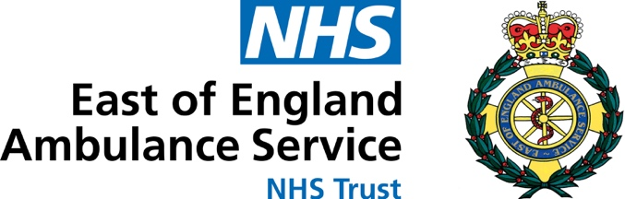

COVID -19 Antibody Testing Data Collection Form

Consultant Lead | Tom Davis
First Name
Surname
Address

Date of Birth
NHS Number
Date Sample Taken
Time Sample Taken
Clinician Taking Sample
Patient Consent for Sample to be
Taken
Patient Consent for Storage of
Sample
Notes

Please return for the FAO of Dr Tom Davis, Medical Director, East of
England Ambulance Service Trust, Whiting Way, Melbourn, Cambs,
SG8 6NA.
Telephone: 01763268700

