Teams background instructions:

How to access the graphics:
- Go to your file explorer folder
- Click ‘This PC’
- Click ‘Windows (C:)
- Select ‘Apps’
- Select the ‘Teams’ folder where both graphics are held.
The filenames should read ‘Teams-WeAreEEAST-01’ and ‘Teams-WeAreEEAST-02’

How to install the graphics:
Open Microsoft Teams and enter a video call.
When the video call begins, click the three dots:
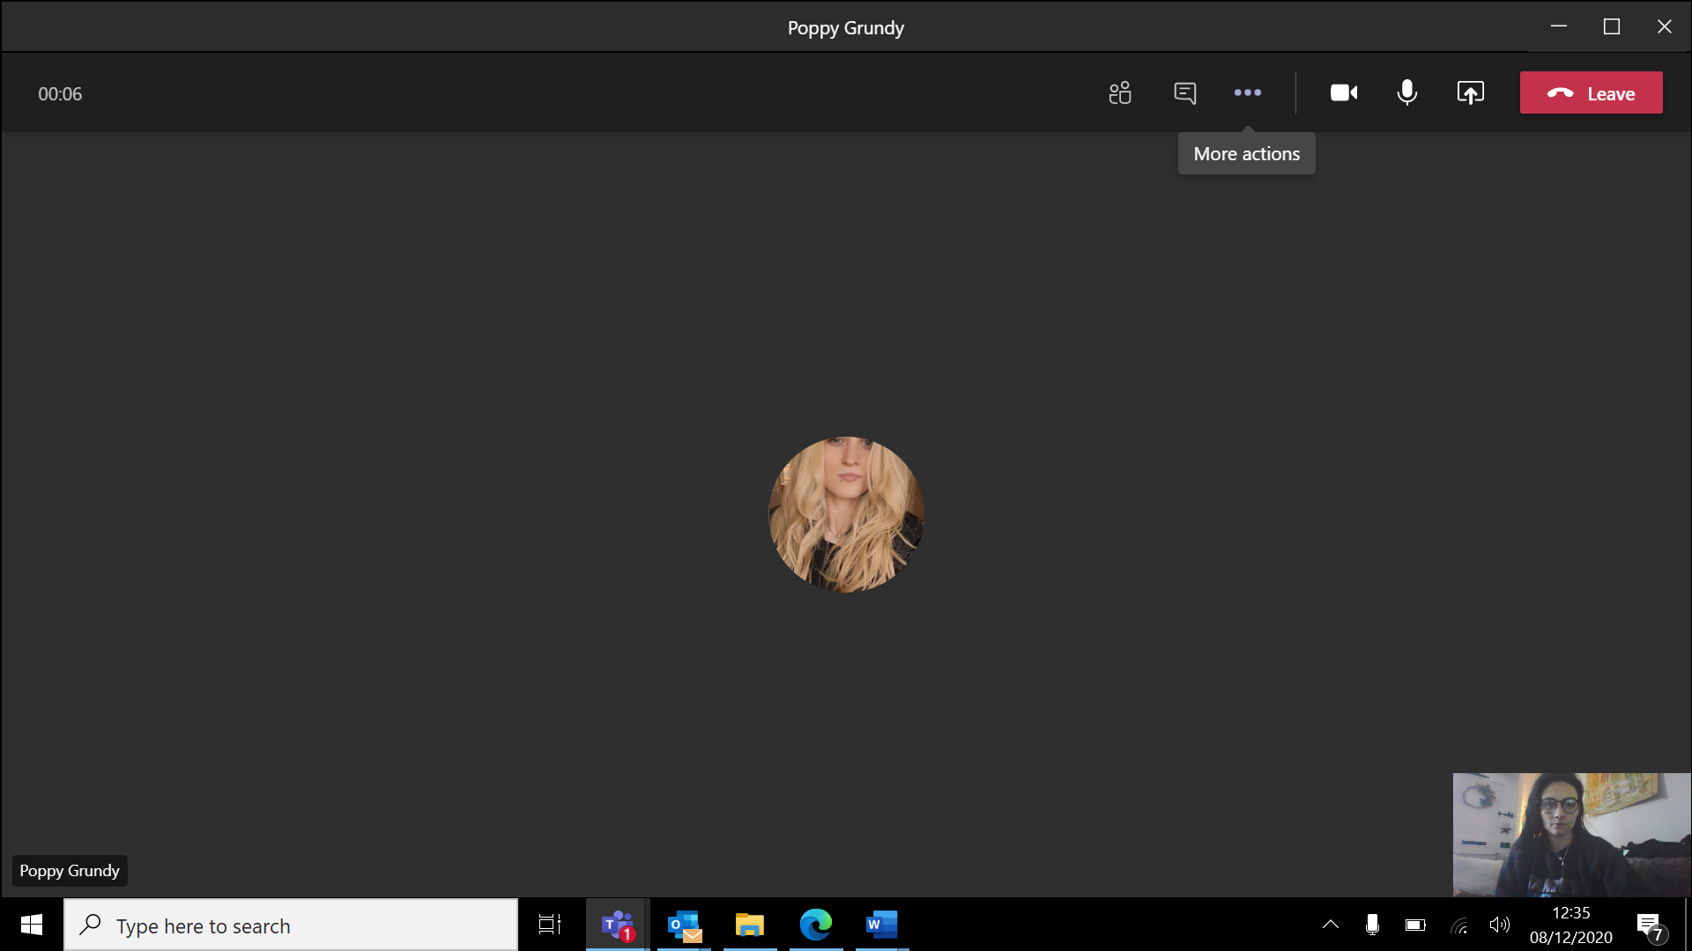

A drop down will appear with options, please select ‘Apply background effects’:
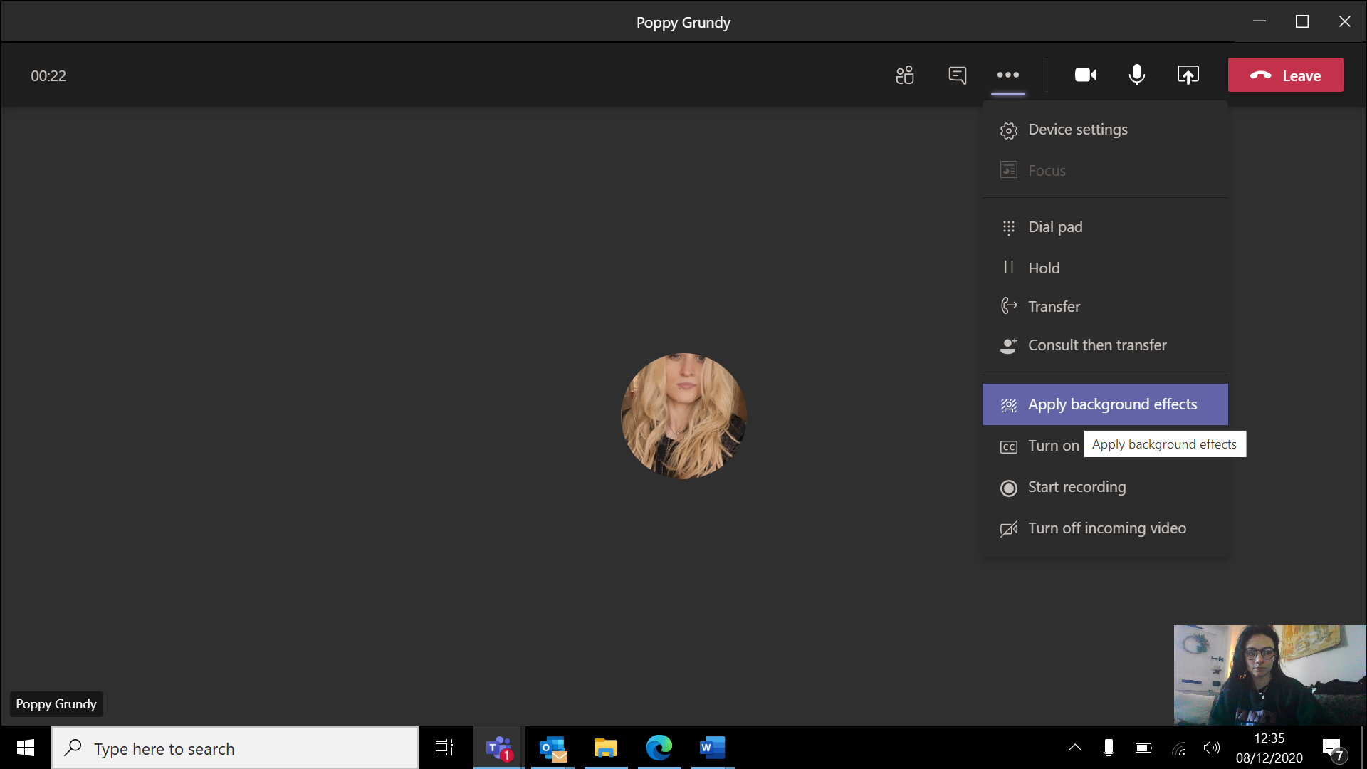

Select ‘+ Add New’:
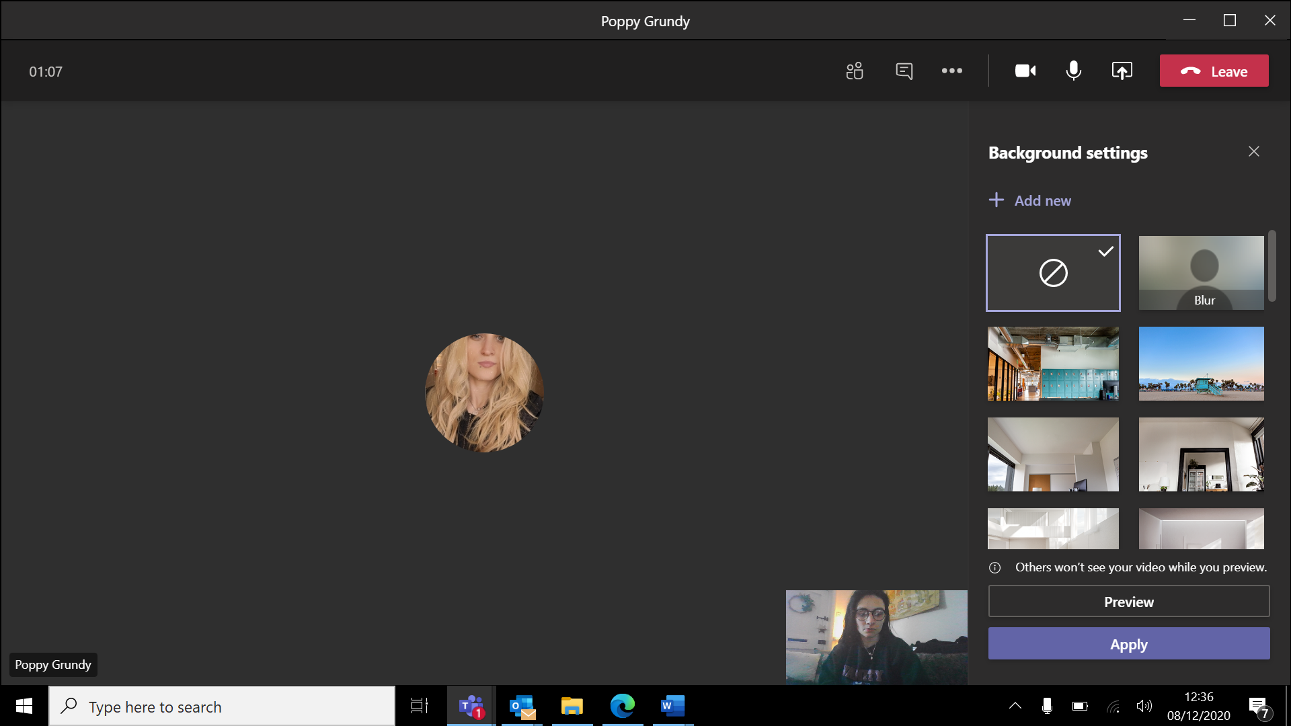

This will open a pop-up box for you to select the Trust background graphic.
Select ‘This PC’ folder, click ‘Windows (C:)’, click ‘Apps’, then select the ‘Teams’ folder. Select image from this folder, and click ‘open’:
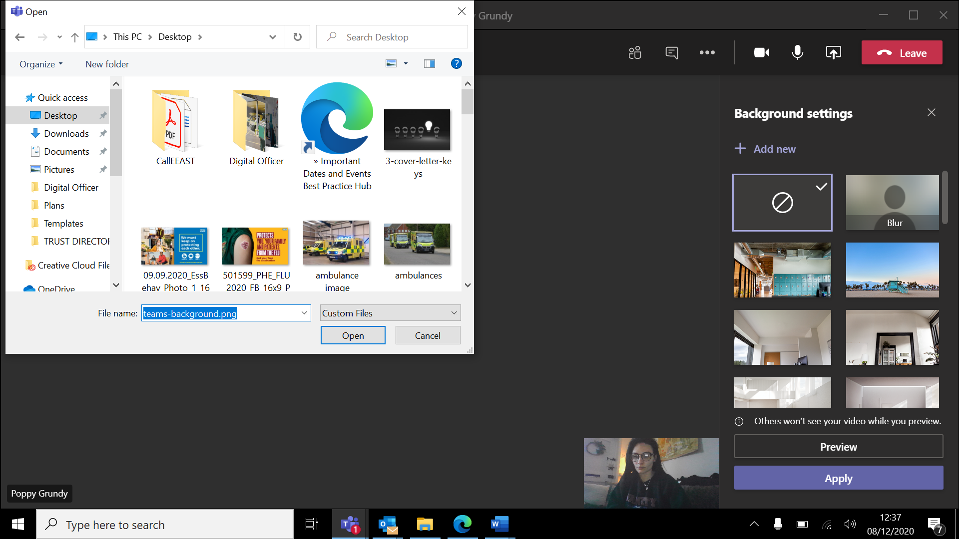

The image will then be uploaded into the list of background images for you. Select the background image you wish to use on your call and click ‘Apply’.
You also have an option to preview the background before applying it, just click ‘preview’.
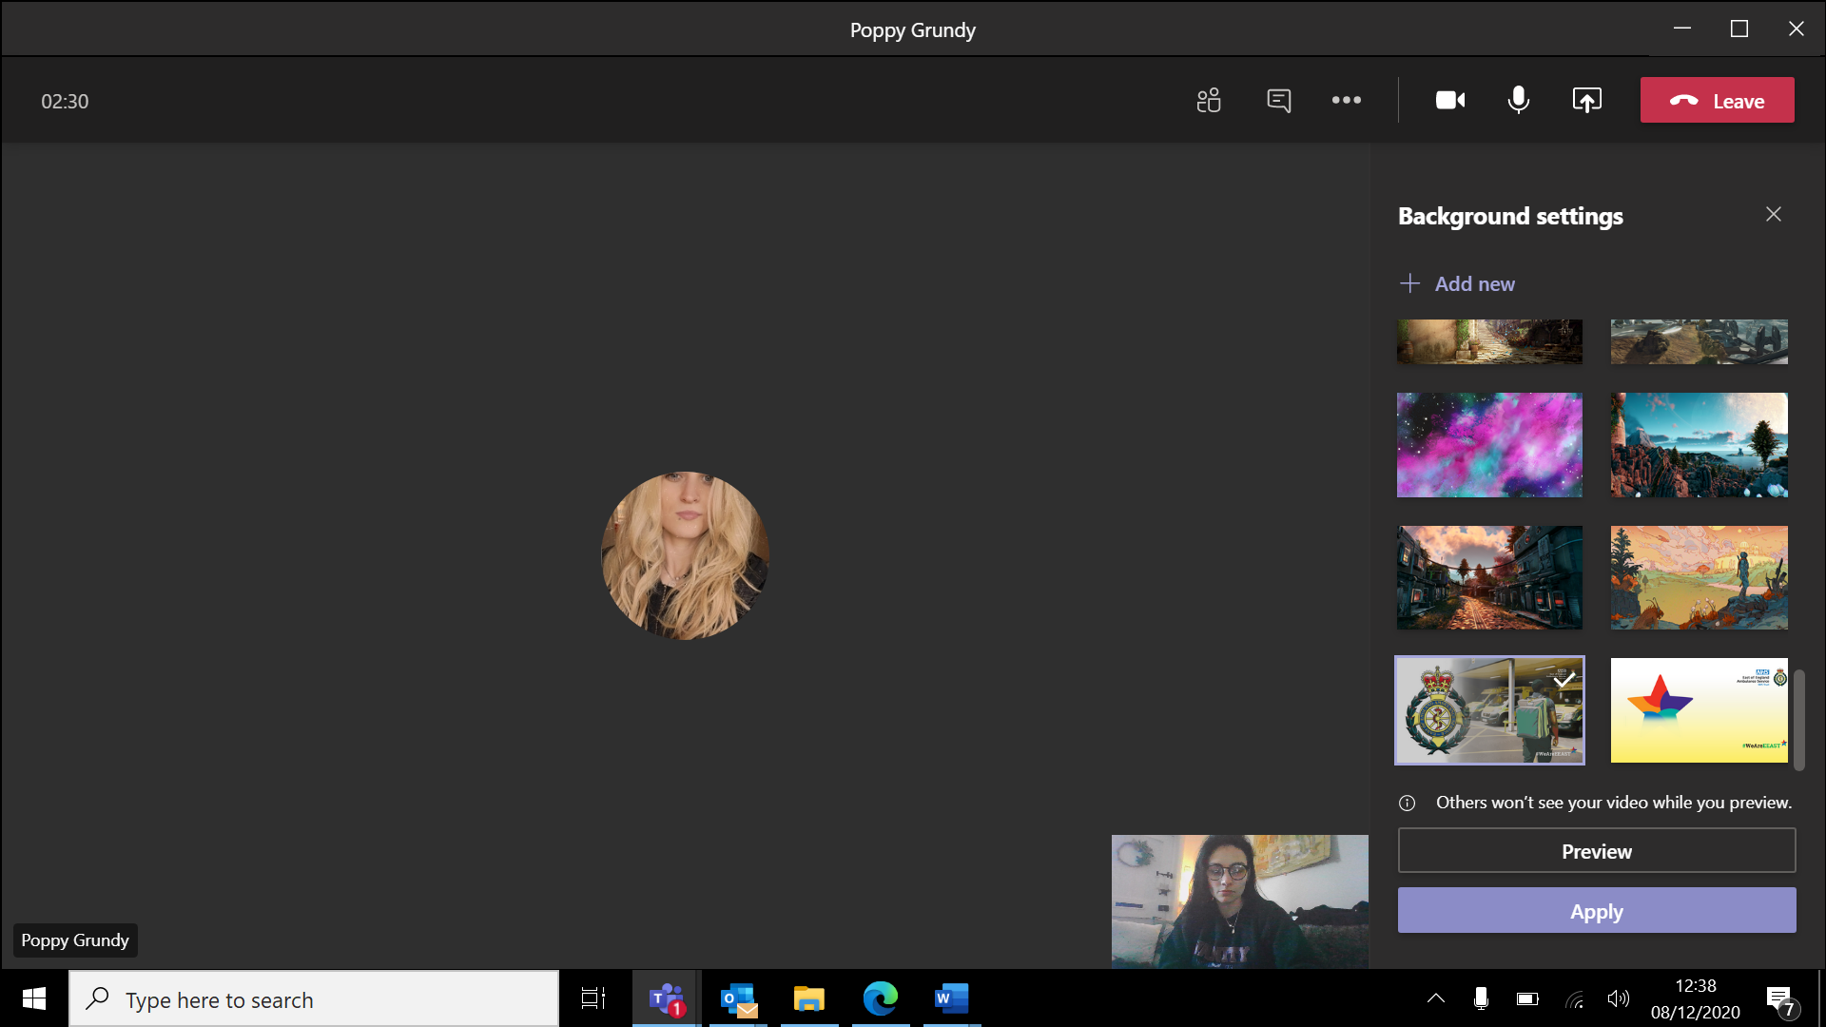
Repeat the process to add second background graphic.

